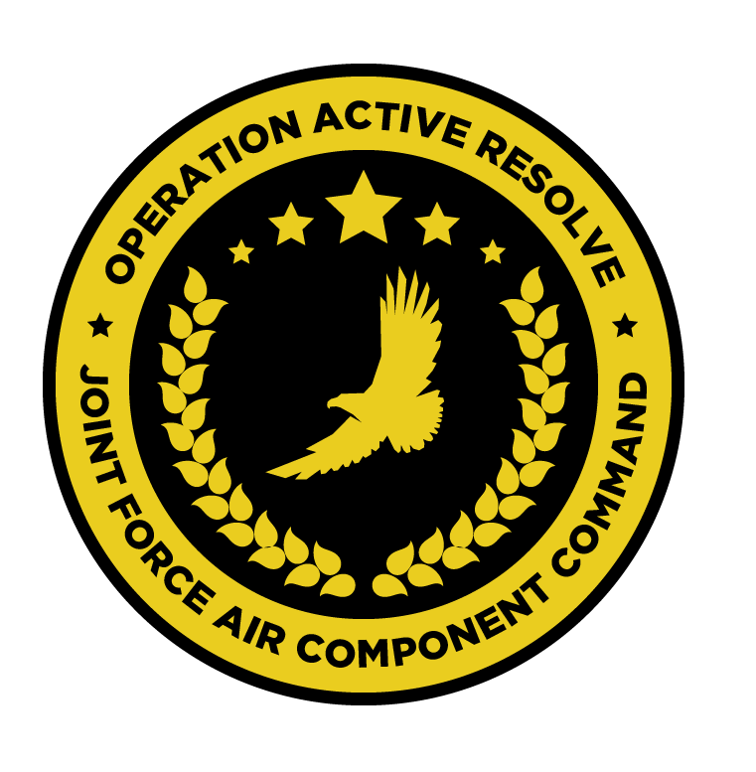

JFACC AIR OPERATIONS DIRECTIVE

OPERATION ACTIVE RESOLVE

D4

# 1. SITUATION

## a. JFC guidance (verbatim).

Priority of effort is on establishing Air Superiority in support of LCC and set conditions

for own operations.

* Start shaping for phase 2 in the operation (Create permissive environment).
* Continue support to LCC
* Be prepared to prepare contingency plans for striking Syrian WMD at short notice (regardless of phase). Expect this plan to be asked for prior to commencing phase 2. ALR: HIGH approved for such a plan.

## b. Enemy situation.

The current enemy situation is defined in VIS INTSUM D3, available at OPAR BRIEF.

## c. Friendly situation (by joint force component).

### Land Component Command (LCC)

#### IV Corps

The 55th Mechanized Division has secured HATAY and have moved forward battalions to screening positions along the FLOT.

The 56th Armor Division has its’ forward elements at the outskirt of Gaziantep. The 56th is preparing for the assault at Gaziantep airfield that will commence in the morning hours of D4.

#### Turkish local forces

The Turkish 33rd Brigade protecting the Ataturk Dam have been defeated by Syrian

forces despite heavy resistance and support from JFACC with CAS. They have withdrawn to the city of Sanliurfa in order to prevent Syrians capturing the airfield.

* Turkish local forces are in static defensive positions and are not in a position to assume offensive operations.
* Turkish local forces consist of BTR-80 and M-113s vehicles
* Turkish local forces are reinforced with coalition JTACs to support with CAS to defend
* against Syrian attacks.

### Maritime Component Command (MCC)

CSG-1 continues to support the mission from CSG-1 operations box.

SAG 1 remains outside the AO, having been directed to support shipping movements elsewhere following the loss of a Coalition logistics ship carrying GBUs.

### Special Operations Component Command (SOCC)

SOF teams are standing by to support with reconnaissance as required and requested by JFACC.

* Three SOF teams are being requested to deploy to theatre in support of the observation of strategic objectives. The request is raised to the SOCC.

# 2. MISSION - The JFACC’s mission statement (verbatim).

JFACC will establish air superiority in the area of operations and defeat Syrian offensive capability in support of CJTF-82’s offensive operations to neutralize Syrian offensive capability to conduct offensives in the region.

# 3. EXECUTION – AIR OPERATIONS

|  |  |
| --- | --- |
| **JFACC’s Intent**   1. **Purpose** 2. **End State** | JFACC’s intent for this day is to focus operations on Gazientep in order to:   * Destroy newly detected SA-6 batteries in the north of Syria that are protecting airspace IVO Gazientep * Significantly attrit the remaining Syrian SHORAD forces located at Gazientep * Build further intelligence on the IADS picture in order to determine whether the capability of IADS SCC West has been restored and what IADS coverage remains near to the Turkish border.   Additionally, in preparation for operations to take place further south in Syria, JFACC seeks to probe the QRA response further south in Syria, specifically those Syrian Airforce assets based at Tiyas.  The VIS intelligence picture is particularly lacking with respect to forces south of Abu al-Duhur and the situation at sea. Friendly forces have now lost two shipments of critical munitions and, accordingly, ISTAR taskings will be allocated to develop the sea picture in support of VIS, JFACC and MCC.  As night falls, JFACC intends to leverage the reduction in the SyAF capability to fight to strike Tiyas airbase with a significant package of friendly forces, the intent being to deny the enemy the use of the airfield.  Alongside this SEAD/DEAD activity, sorties will be allocated to conduct SEAD/DEAD operations in eastern Syria in order to permit safe passage towards the southern extent of the AO without overflying protected areas.  Finally, throughout the day, taskings will be allocated to the attrition of Syrian ground forces in support of the LCC.  The end state of this ATO sees the freedom of manoeuvre around Gazientep for low-level strike assets to provide support to friendly ground forces conducting their offensive. Additionally, VIS will be provided with significant additional intelligence to understand the enemy IADS picture in the north of Syria and the border with Turkey, eastern Syria, the area surrounding Hama and the QRA capabilities of the Syrian airforce based in southern Syria.  Additionally, VIS, JFACC and MCC will be better equipped with information relating to the operations of Syria and its’ allies at sea, informing decisions relating to the deployment of the CSG and the passage of allied shipping.  Come the end of D4, the Syrian air force will be denied the use of Tiyas AB. |
| **Execution** What to do, when. – Any detailed instructions if needed | Flights will be tasked to engage SHORAD and SAM threats IVO Gaziantep, including the SA-6 sites reported from D3 (D3.1-005 and D3.2-004). A two-ship of CAP will be established at X16 in support of this effort, cleared to operate in a block from FL300 and above.  Flights will then be tasked to proceed to the Gaziantep area after CAP is established in order to begin Armed Reconnaissance, under the direction of a SCAR as outlined in the ATO, with deconfliction to be coordinated by the SCAR.  A package of flights will be tasked separately to undertake a number of specific intelligence taskings:   * Determine the remaining Syrian threat at sea and in port (IR17) * Determine the presence of Russian naval vessels at sea and in port (IR17) * Determine whether the Russian Kilo class submarine remains in port (IR17) * Determine the SAM presence along the West coast of Syria, north of Lebanon * Determine ‘trigger lines’ for Syrian QRA in the South   In order to deconflict from operations in the vicinty of Gazientep, this package must remain west and south of Aleppo at all times. The engagement of Syrian Air Forces in this area should be the responsibility of CAP NORTH.  Alongside the SCAR operations conducted at Gazientep, a flight will be delegated responsibility for killboxes AD, AE, BD and BE. This flight will be responsible for locating and reporting on the location of the armoured brigade observed to have left Gaziantep heading East on D3. In order to deconflict with operations at Gaziantep, this flight must transit into and out of the killboxes below FL150 crossing ACP IRWIN and leveraging the defined minimum-risk routes, and must not cross ACP IRWIN inbound the Killboxes until after CAP NORTH is established.  As night falls, a package will depart and muster overhead ACP ATHENS, not below FL150, with orders to press south into Syrian territory and strike Tiyas airbase, denying the enemy the use of the airfield. This large package will be provided with both an escort and a sweep as part of the package.  In support of the ongoing LCC offensive at Gaziantep, flights will be tasked to perform Armed Reconnaissance in the Gaziantep area, with at least one flight being considered an airborne CAS standby should an air request be received from the LCC.  These flights will be supported by a CAP flight to ensure their protection whilst strikes occur at Tiyas and should not be on station until CAP is established. |
| **Focus of effort by objective** | In accordance with JFACC objectives 1.1 and 1.2, this AOD predominantly seeks to reduce the threat posed by SHORAD and SAM systems situated IVO Gazientep. The majority of sorties in this both ATOs will be directed in support of this objectives.  Additional sorties will be allocated to:   * 2.1 – provide requested LCC air support as far as possible to achieve LCC’s Main Efforts. * Develop the friendly Intelligence picture, particularly at sea. |
| **Acceptable level of risk**. (including for AWACS and tankers: forward or rear) | The accepted level of risk throughout this AOD is MEDIUM, **other than:**   * DEAD efforts targeting SA-6 sites should accept **HIGH RISK.** * The strike package tasked with denying the use of Tiyas should accept **HIGH RISK.** |
| **Collateral damage and civilian casualty guidance** | Every attempt should be taken to minimise collateral damage in the execution of these missions.  Suspected civilian casualties should be reported as soon as is practicable. |
| **TST guidance** | Where they are identified, items from the TST matrix must be prosecuted. The outcome should be reported on the in-flight report net. If prosecution is not possible, the location must be reported for re-tasking.   |  |  |  |  |  |  | | --- | --- | --- | --- | --- | --- | | **PRIORITY** | **TARGET** | **DESIRED EFFECT** | **RISK LEVEL** | **STATUS** | **RMKS** | | 1 | SCUD | Destroy | MEDIUM | Unlocated | N/A | |
| **Intelligence, Surveillance, Reconnaissance (ISR)** – If any effort should be done to support VIS with ISR to answer information gaps from VIS. | All intelligence and BDA should be submitted via Campaign Manager, and necessary images placed in #bda-reports on discord IAW SPINS.  The following ISRs should be supported in this AOD:   1. Can the location of the Kilo class Submarine be determined? 2. Are Silkworm Missile Batteries located along the Syrian coast? 3. IR9 – Location of IADS SAMs 4. IR 5 – Confirmation 11th Mech DIV IVO Gaziantep, air defences in place and disposition of manoeuvre units 5. IR12 – Confirm presence and origin of Syrian QRA 6. IR17 – Confirm the presence and type of Russian or Syrian naval units at sea 7. IR14 – Confirm presence and type of air defence IVO Tartus 8. IR2 – Location of 2nd Corps Rocket Arty Bns 9. IR7 – Location of 21st Mech DIV and 22nd Mot DIV and disposition of manoeuvre units |
| **Other issues** | N/A |
| **Direction and Guidance** | Aircrews must remain clear of Jordanian airspace at all times. Munitions must not be expended which may encroach on Jordanian airspace.  Munitions may not be expended in the direction of Basel Al Assad And Tartarus in order to avoid Russian involvement in the conflict. |

# 4. ADMINISTRATION AND LOGISTICS

Due to other ongoing major military operations, the munitions are limited in accordance with the ‘[available ordnance](https://132nd-vwing.github.io/OPAR-Brief/MISSION%20INFORMATION/OPAR%20Ordnance.pdf)’ publication available at OPAR Brief. **Further limitations may be imposed by JFACC and will be detailed in the ATO.**

**Active Tanker Tracks –** ARCO-1, SHELL-3 and SHELL 4 as published in D4 ACO

# 5. COMMAND AND CONTROL

BULLSEYE MARY is defined at N35 53.950 E037 40.600.

There are no other specific C2 considerations for these missions. Refer to the Command, Control and Communications section of the JAOP.